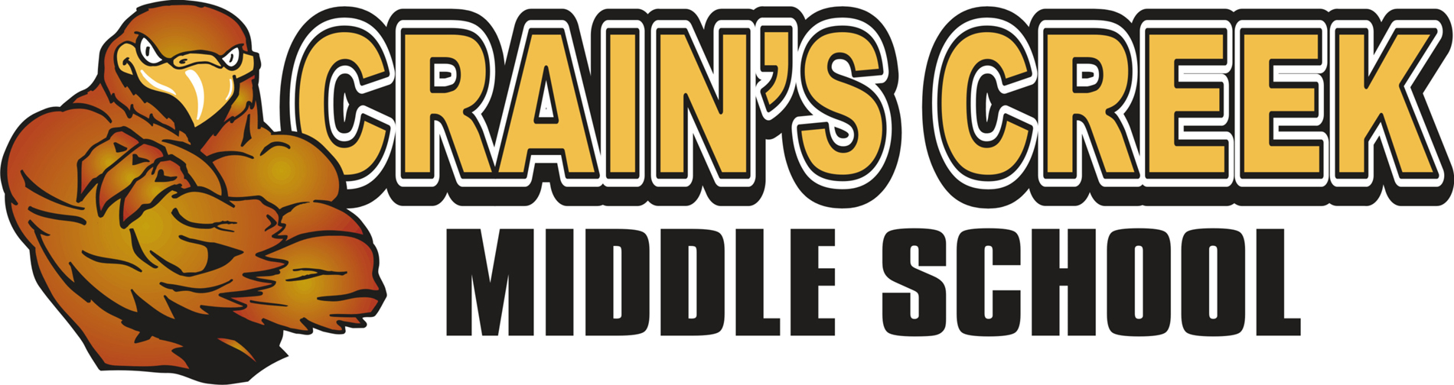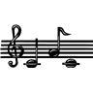
Instrumentally Speaking Kim Sparks, Teacher

Welcome to CCMS Instrumentally Speaking! As a member of the Instrumentally Speaking class, your child will find this year to be full of musical experiences through the exploration of a variety of instruments while expanding his/her knowledge about the performing arts.

COURSE DESCRIPTION
Instrumentally Speaking students will find themselves engaged in activities through
1. Playing a variety of instruments including, hand drums, Orff (Barred) Instruments, Electronic Keyboards, etc
2. Using technology to produce and compose original musical pieces
3. Discovering the use of a voice as a musical instrument
4. Analyzing music that correlates with the Social Studies and Language Arts curriculum.

Moore County Schools’ mission is to create an environment for 21st century learning. Using technology is a crucial element in reaching this goal. Therefore the use technology will become part of student learning, assignments and evaluation. You will soon be able to access my web page from the Crain’s Creek Middle School website for information throughout the school year.

ENCORE EXPECTATIONS
The Encore Teachers will be endorsing the same expectations for all students this year
Each Encore teacher will explain the use of each expectation within his/her classroom setting.
Below are the Encore Expectations
Falcon Pride
- I am Prompt and Prepared.
- I am Responsible and Respectful.
- I am Honest.
- I am Dependable
- I am an Enthusiastic learner
- Each six weeks, a student with three combined Encore tardies will lose his/her privilege to attend the celebration.

Students who work hard and maintain a positive attitude will be invited to the 6 weeks’ Encore Celebration.

CONSEQUENCES Positive Rewards
1st offense- Write an expectation plan. Shout Out “Bravo”
2nd offense - Write an expectation plan. The plan must be returned Treats
the following day with parent’s/guardian’s signature. Bravo phone call
Parents are contacted. Bravo Award
3rd offense – Write a summary of the previous offenses including the 3rd. Fun Time
Office referral.
Participation in the Encore Celebration is denied. Encore Celebration

GRADES/GRADING
The student’s grade will be an average of the following items:
- Weekly Participation Classwork = 100 points
- Concept Quizzes/ Skills Evaluations = 200 points

I am excited to begin this musical journey with my students. I believe it is my job to offer a safe and engaging classroom in which students feel free to learn and create. Please feel free to contact me at the school at 245-3796 or by email at ksparks@ncmcs.org . It is essential that each student understand what’s expected of him or her to succeed, as well as to know that they have your support throughout this year.

Thank you and I look forward to a great year!

Sincerely,
Kim Sparks
Choral/Instrumentally Speaking

Please return the bottom half of this sheet by this Friday, August 28th.

******************************************************************************************.

CCMS Instrumentally Speaking Class Commitment Form

I, the student, have read the contents of this letter and understand the expectations that I am to uphold while participating in this class.

Student Name (Please Print) _________________________________

Student Signature _________________________________________
Student Grade: _______

I, the parent/guardian, have read the contents of this letter and understand the expectations of my child for this class. I understand that it is my responsibility to provide support for my child’s success for this class.

Parent/Guardian Signature _____________________________________

You may contact me by:

Home Phone:______________________ Work/Cell Phone:__________________

E-Mail:____________________________________________

