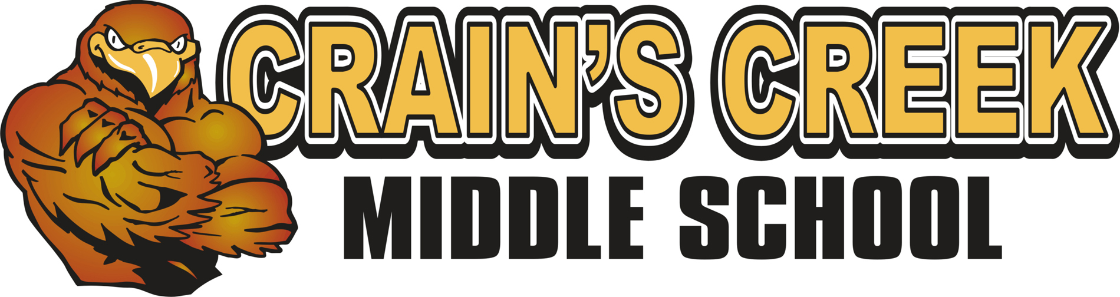 7th/ 8th grade Chorus Kim Sparks, Director 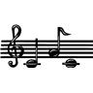

Welcome to Crain’s Creek Middle School Chorus! Members of the CCMS Chorus will be exploring the art of vocal music. The 7th and 8th grade choral students will available to audition to participate in All County Chorus, the North Carolina Middle School Honors Chorus in the fall and the North Carolina Middle School All-State Chorus in the spring. Those students interested in one/all of these opportunities will receive information about the events as they arise throughout the school year.

COURSE DESCRIPTION
Chorus students will focus on 2, 3 and 4-part singing and music theory. Students will sing music from a variety of genres and historical periods relating to their Social Studies curriculum as well as popular songs. Literacy will also be an important part of our music studies to help with our school goals.

PERFORMANCES
Our concerts will be the result of student learning. It is extremely important that students attend each and every concert! Such events will represent the hard work and learning that has been present throughout the preparation of the performance. It is known in sports that the team is only as good as the hard work and presence of each player to be successful at each game. The same is true as a member of a choral group! Early calendar planning can help create a balance between the many activities that students are involved in throughout the school year.

CALENDAR
You will receive a calendar with choral activities soon. So, please plan ahead now! Participation in these events will be considered as an academic grade for the nine week period. Our main concerts are held in December and April/May, as well as a musical in the spring.

CONCERT DRESS
Chorus shirts and khaki pants will be our formal attire. Information for ordering shirts will be distributed soon. Arrangements for payment may be discussed as needed.

MATERIALS
Students are asked to donate a package of pencils for us to use throughout the year. Donated boxes of tissue would be great, but not required!

Moore County Schools’ mission is to create an environment for 21st century learning. Using technology is a crucial element in reaching this goal. Therefore the use technology will become part of student learning, assignments and evaluation. You will soon be able to access my webpage from the Crain’s Creek Middle School website for information throughout the school year. Personal electronic devices are to be powered down and put away before the student enters the room. If the device is out during instruction without permission, the device will be collected and kept until the end of the school day. It will be the student’s responsibility to retrieve the item at that point. Chrome books will be used as needed with lessons.

ENCORE EXPECTATIONS
The Encore Teachers will be endorsing the same expectations for all students this year
Each Encore teacher will explain the use of each expectation within his/her classroom setting.
Below are the Encore Expectations
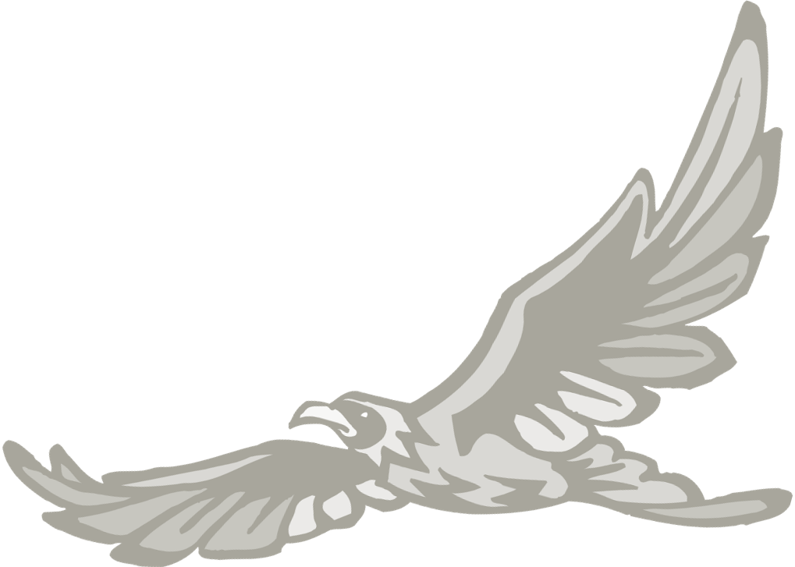
Falcon Pride
- Prepared
- Respectful
- Involved
- Dependable
- Encouraging

- Each nine weeks, a student with three combined Encore tardies will lose his/her privilege to attend the celebration.

Students who work hard and maintain a positive attitude will be invited to the 9 weeks’ Encore Celebration.

CONSEQUENCES Positive Rewards
1st offense- Write an expectation plan in class. Discuss with teacher Shout Out “Bravo”
2nd offense - Write a new expectation plan. The plan must be returned Treats
the following day with parent’s/guardian’s signature. Bravo phone call
Parents are contacted by teacher. Fun Time
3rd offense – Office Referral Encore Celebration
Participation in the Encore Celebration is denied.

GRADES/GRADING
The student’s grade will be an average of the following items:
- Weekly Participation = 100 points
- Concept/ skills Quizzes/ Evaluations = 200 points
- Performances = 200 points
Participation in each concert will be counted as a grade for the marking period.
***If, in the event a student should miss a concert, the student will be given an assignment. The assignment (signed by the parent) must be returned by the due date set by the teacher. An explanation of absence would be appreciated.

I am excited to begin this musical journey with my students. I believe it is my job to offer a safe and engaging classroom in which students feel free to learn and create. Please feel free to contact me at the school at 245-3796 or by email at ksparks@ncmcs.org . It is essential that each student understand that you are aware of what’s expected of him or her to succeed as well as your support throughout this year. Please sign and return the commitment/ information form to me as soon as possible.

Thank you and I look forward to a great year!

Sincerely,
Kim Sparks, Director

Please return this page only. The letter is for you to keep at home.

CCMS Singing Falcon’s Commitment Form

I, the student, have read the contents of this letter and understand the expectations that I am to uphold as a member of the CCMS Singing Falcons.

I will
- Commit to being the best choral member that I can be throughout the year
- Enter the room with a positive attitude, ready to learn
- Help the group reach the highest goal possible for each and every day
- Care for my fellow members
- Attend all performances to ensure the success of the group
- Uphold the Encore Falcon Pride Expectations

Student Name (Please Print) _________________________________

Student Signature _________________________________________
Student Grade: _______

I, the parent/guardian, have read the contents of this letter and understand the expectations of my child as a member of the CCMS singing Falcons. I understand that my child will need to obtain a choral outfit for performances. I understand that it is my responsibility to provide transportation for my child to any after school events.

Parent/Guardian Signature _____________________________________

Please check any or all of the following opportunities to volunteer for the CCMS Singing Falcons.

_____ I will accompany the group during a performance. I play the _______________.
_____ I will join in a rehearsal as needed. I can read music. I am a soprano, alto, tenor, bass.
( Please circle your vocal range.)
_____ I will help with fundraising.
_____ I will organize the End of the Year Concert Reception
_____ I will donate candy/ baked goods as needed

You may contact me by:

Home Phone:______________________ Work/Cell Phone:__________________

E-Mail:____________________________________________

Emergency contact :_______________________________ Phone:__________________

